own Deal Fund Programme Financials to 31st March 2026

The full project actuals spent from inception to 31st March 2026 was £26.2m against an overall budget of £58.7m and forecast of £59m, the 2025/26 current financial year actual costs for 12 months to 31st March 26 were £0.4m under budget, please refer to page two for more information. Year End - Please be aware that year end accruals have not yet been submitted and therefore actioned, as the deadline is later, any material adjustments will be noted in the following months financial report.
CY Actuals to 31st March 2026 £16.0m
CY 11 Months budget to 31st March 2026 £16.4m
Current Year (CY) Variance - Actuals under budget £ 0.4m
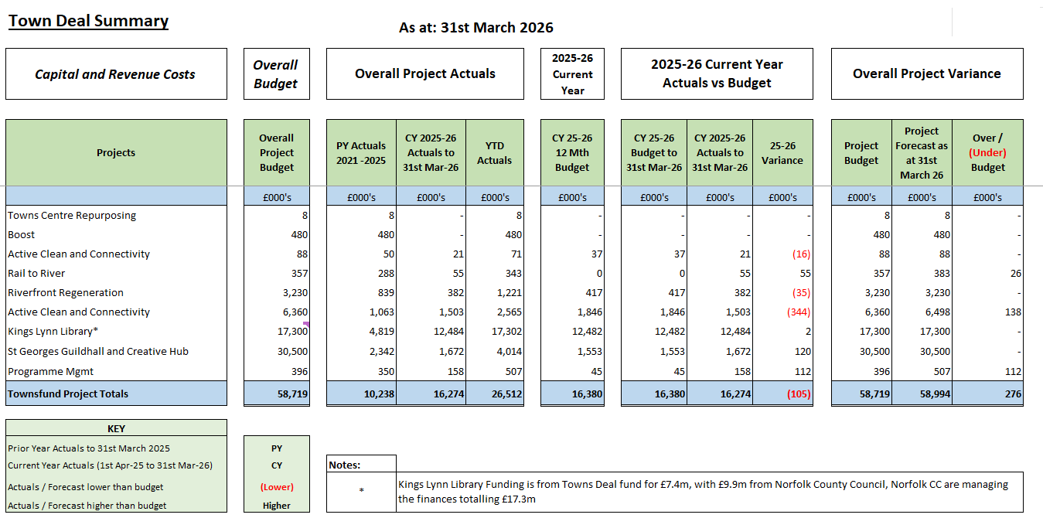
Overall full project costs to date are £26.3m, 2025-26 current year actuals are £16m against a £16.4m CY budget giving £0.4m actuals lower than budgeted
The overall estimated projected costs for each project vs the overall budget shows that the total projected variance is £0.3m over budget, due to a forecast of £59m compared to £58.7m of budget, the £0.3m overspend is primarily due Active Clean and Connectivity due to additional unexpected costs which haven’t utilised the client contingency (£0.25m) and programme management costs which are estimated to be over the budget due to higher staff capitalisation costs.

