P.21-14 |  |  | Riverfront Regeneration Project Highlight Report
Project Name: |  |  | Riverfront Regeneration |  |  |  | Project Manager |  |  |  | Abigail Rawlings/ Pulse |  |  |  | Project Sponsor: |  |  |  | Duncan  Hall |  |  | Report covers period of: |  |  |  | March 2026
Capital Code: |  |  |  |  | C9066 |  |  |  |  | Client Dept: |  |  |  | Regeneration |  |  |  |  |  | Lead Designer: |  |  |  | Another Kind Architects
 |  |  |  |  |  |  |  |  |  |  |  |  |  |  |  |  |  |  |  | Cost Consultant: |  |  |  | Andrew Morton Associates
Project Code: |  |  |  |  | P.21-14 |  |  |  |  | End User (if applicable) |  |  |  | n/a |  |  |  |  |  | Contractor on Site: |  |  |  | Dryside- E.N Suiters &Sons LTD
Management Summary
 |  |  |  | 1.Overall Status |  |  |  |  | 2.1 Risks |  |  | 2.2. Issues |  |  |  |  |  | 3.Financials |  |  |  |  | 4.Timelines |  |  |  | 5.Resources
This Report |  |  |  | A |  |  |  |  | R |  |  | A |  |  |  |  |  | A |  |  |  |  | A |  |  |  | G
Last Report |  |  |  | A |  |  |  |  | R |  |  | A |  |  |  |  |  | A |  |  |  |  | A |  |  |  | G
Project Definition
Project Stage: Custom House RIBA Stage 4 Detailed Design
Dryside RIBA 5 Construction
Objectives: Development of the design to enable the Riverfront area to become an attractive destination space increasing footfall promoting day and nighttime use, facilitating events etc.
Scope: Renovation of the Custom House, improvements to King’s Staithe Square, South Quay public realm and dry side facilities
1. Overall Status (high-level summary)
Overall RAG Status is AMBER.
- The Devil’s Alley component of the project will now proceed under the Pride in Place (PiP) Programme funding.
- A Project Adjustment Request has been submitted to MHCLG, formalising the revised scope, outputs, and funding allocations.
- As part of this adjustment, £2 million will be reallocated from the Riverfront Regeneration to the St George’s Guildhall and Creative Hub project. Guidance on completing this process is expected shortly.
- Updated Business Plan and Economic Case to reflect the new scope has been prepared with a preferred option for Custom House identified.
- A comprehensive reprogramming exercise has also been carried out to align the project timeline while keeping as close to original programme as possible.
- Planning permission and listed building consent granted for both the Custom House and Dryside.
- Works to the Dryside started in January and are due to be completed in July 2026.
- A historical accounting issue identified that impacted the remaining available budget has sought resolution through the wider programme underspend and funding re-allocation (£595k). Following approval, the capital project is now fully funded.
1.1 Decisions required by the Neighbourhood Board
- None
1.2 Achievements during this period
- Custom House works package tender went live and closed 30th March 2026.
- Contractor site visit day for bidders took place on 11th March, with 11 contractors attending.
- Draft licence issued from Custom House building owner for permission for works, some small amendments to be made before signing.
- Cabinet Paper submitted to seek approval to ‘let’ the contract for works.
- Work continues to progress at Dryside, with the second valuation submitted for payment.
- Fortnightly meetings continue with Public Open Space/Property Services team to confirm operational handover for Dryside at completion.
- Arrangements for CCTV and security access confirmed with BCKLWN’s ops team.
- Meeting arranged with Norfolk Museum Services for removal of their items from Custom House for duration of works.
- Devil’s Alley and area behind Dryside and Sommerfeld and Thomas building has been cleared of overgrown vegetation with instruction to Public Open Space team to continue with bimonthly maintenance of site.

Priorities for next period:
- Get Licence required to give permission for works signed with Custom House Building Owner.
- Review tender returns and progress aware for works with successful bidder.
- Take cabinet paper to Regeneration and Development Panel on 31st March and then Cabinet on 23rd April, for approval to ‘let; Custom House contract.
- Continue arrangements for removal of unfixed fittings from Custom House (liaison with Property Team and Norfolk Museum Services). Including Parliament Clock, on loan from Liverpool Museums.
- Continue to explore interpretation/volunteering options for activation of Custom House after works.

2. Risks and Issues
2.1 Key Risks [all red and increasing amber] – something that may happen
Risk ID  (4/69) | Risk Title |  |  |  |  |  |  |  | Description |  |  |  |  |  |  | RAG Status |  | Risk Category |  |  |  |  | Mitigation |  |  |  |  | Dated Comments
61 | Custom House Building Owner permissions/Lease |  |  |  |  |  |  |  | Building owner may not give permissions for works, current lease does not allow for changes to building without re-instatement. Existing lease needs to be varied ahead of works starting/contract being let. |  |  |  |  |  |  | R |  | Legal |  |  |  |  | Risk remains red as despite the mitigations noted below, until finalised legally this is the highest risk to this project. Ongoing engagement with building owner throughout the project. As per lease agreement, owner gave permission prior to submission of planning application.  Legal and Property teams working on lease variation to allow for works. Project Officer and Cultural Officer have fed into these discussions to ensure variation is appropriate with potential future uses. Building owner is in agreement with the proposed terms to the licence. |  |  |  |  | 27.03.26
68 | Failure to agree lease variation/Licence with Building Owner within project timelines. |  |  |  |  |  |  |  | The current lease does not allow for works to the building and needs to be varied. Project timelines are to be in contract by May 2026 but the lease variation/licence could take longer than this, delaying the tender/contracting process, leading to additional costs. Staff resource issue as the Interim AD for Property and Projects who is leading the discussions is leaving the council at the end of March. |  |  |  |  |  |  | R |  | Legal |  |  |  |  | Risk remains red as despite the mitigations noted below, this is the highest risk to this project.  Interim AD for Property and Projects chasing building owner and representatives to move process along. Call with building owner to informally re-confirm agreement for works verbally. Meeting held with owner’s appointed surveyor to discuss the delay and book in required schedule of condition. |  |  |  |  | 27.03.26
69 | Cabinet approval not given to “let” Custom House works contract. |  |  |  |  |  |  |  | Cabinet approval to “let” the Custom House contract is not in place. The next meeting is 23rd April, the contract cannot be signed until then and the following “call-in” period. |  |  |  |  |  |  | A |  | Governance |  |  |  |  | Cabinet paper to set out project progress and funding allocations to go through the correct pre cabinet channels. Paper will be taken through the approval channels. Project Sponsor and Member to give paper. |  |  |  |  | 27.03.26
70 | Tender responses for Custom House Works come in higher than expected. |  |  |  |  |  |  |  | Tender responses to Custom House Works package may come in higher than anticipated, resulting in a funding gap or changes to scope. |  |  |  |  |  |  | A |  | Cost |  |  |  |  | Project team to review responses with Quantity Surveyor and Procurement Officer. Responses due 30 March 2026 and will be reviewed from 7 April 2026. |  |  |  |  | 27.03.26
2.2 Key Issues [all red and increasing amber] – something that has happened
Issue ID  (1/18) | Issue Title |  |  |  |  |  |  |  | Description |  |  |  |  |  |  | RAG Status |  | Issue Type |  |  |  |  | Resolution Plan |  |  |  |  | Dated Comments
13 | Available budget refined |  |  |  |  |  |  |  | Historical accounting error has been identified. After investigation this reduced available budget to less than required for current scheme, while this has been resolved the budget for interpretation needs to be sought. |  |  |  |  |  |  | A |  | Cost. |  |  |  |  | Element of issue remains open.  An underspend from another project has been redirected via a Project Adjustment Request, along with some small areas of value engineering has closed the budget gap. However, this budget for capital works is not inclusive of an interpretation budget. Budget for interpretation will have to be sought independently. |  |  |  |  | 27.03.26
3.1 Project Financials
3.2 Financial Commentary
The financials RAG rating is maintained at AMBER
- Actuals to date are £1.22m against an overall forecasted projected costs of £3.2m and a budget of £3.2m and on budget.
- Contingency of circa 10% is included within the £3.2m of £0.3m.
3.3 Project Contingency and Change Control
Change Ref |  | Description |  |  |  | Cost Impact |  | Programme Impact |  |  |  |  | Other Impact |  |  |  | RAG Status |  |  |  | Approval given by |  |  |  | Date of change
 |  | N/A

4. Timelines – High Level Milestones
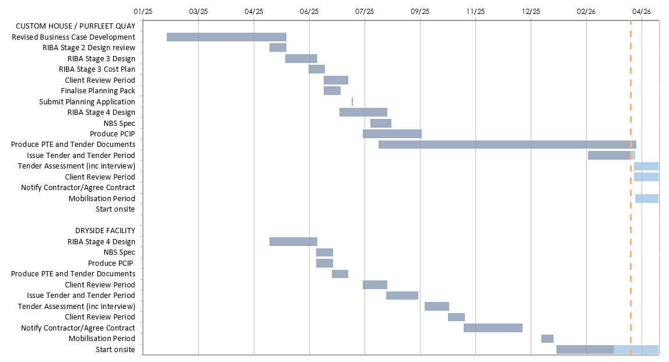
4.1 Timelines Commentary
The Timelines RAG rating is maintained at AMBER
- Timelines reprofiled with the new design team have been split into 2 separate work streams,
  - Custom House/Purfleet Quay
  - Dryside Facilities.
- Confidence remains that the programme is achievable with minor delays. Focus remains to stick to the original programme as much as possible despite the lifting of the March 2026 spend deadline from MHCLG.
- Current areas of risk include Cabinet approval processes to” let” the contract, timescale for licence to carry out works being granted from building owner, tender process and unforeseen issues during the construction phase.
- The proposed start date for works has been delayed by approx. 4 weeks at the Custom House while the project team seek appropriate approvals via the cabinet meeting process.
5. Resources Commentary
Resources RAG rating remains GREEN
- Following procurement of design team and project PM and QS mitigating risk.
6. Communications and Engagement
- Letters went out to all residents of South Quay and Nelson Street, to let them know about the vegetation clearance at Devil’s Alley. Members and Riverfront Stakeholders also included in comms.
7. Outputs and Outcomes
Outputs
Description |  |  |  |  | Target |  |  |  | Full Scheme revised outputs, agreed by KLNB and BCKLWN Cabinet July 2024 and 2025
Amount of rehabilitated land |  |  |  |  | 3000m2
Number of sites cleared |  |  |  |  | 1
Number of public amenities / facilities created |  |  |  |  | 1
Number of historic landmarks and buildings refurbished |  |  |  |  | 2
Amount of floorspace (commercial, residential, industrial) created |  |  |  |  | 4000m2
Number of temporary FT jobs supported during project implementation |  |  |  |  | 154
Number of FTE jobs created and safeguarded |  |  |  |  | 12.1
Amount of public realm enhanced |  |  |  |  | 7845m2
7.2 Outcomes
Description |  |  |  |  | Target |  |  |  | Note
Remediation and development of abandoned site
Upgraded historic landmark site
Improved perception of place by residents, visitors and businesses
8. Other Matters
Item |  |  |  |  | Comment
General stage progress |  |  |  |  | RIBA Stage 4 design complete. Second cycle of consultation with Historic England completed ahead of planning submission for Custom House. Dry Side Facilities planning application has been granted and works started. Devil’s Alley planning submission has now been withdrawn and removed from the project scope.
Procurement progress |  |  |  |  | Professional team:  Architect Led Design Team: Anotherkind Architects  Quantity Surveyor: Andrew Morton Associates  Project Managers: Pulse  Contract works: Dryside facilities, Custom House.  Consideration was given to linking to the Guildhall procurement, but it was considered high risk tying the projects together as it could be readily derailed by delays on the Guildhall which jeopardises two Town Deal projects.
Proposed form of contract |  |  |  |  | JCT - a traditional contract for the Custom House and Dry Side facilities.
Proposed route to market |  |  |  |  | Use of Framework to be considered if required.
Surveys Status |  |  |  |  | Surveys carried out at Custom House, Devil’s Alley (prior to pause of this element) and Dryside.
Stakeholder engagement (comms) |  |  |  |  | Stakeholder engagement strategy development in progress for the project including residents, businesses, and wider community.
Local schemes / dependencies |  |  |  |  | Project to align with Guildhall/Rail to River where possible for consistency of materials.
9. Approved Documents
 |  | OBC  [RIBA 0 Approval] |  | Client Brief [RIBA 1 Initiation] | Resource Brief |  |  | PID  [RIBA 1 Gateway] |  | PID Update  [RIBA 2 Gateway] | PID Update  [RIBA 3 Gateway] |  | PID Update  [RIBA 4 Design) |  | Final PID  [pre-post tender]
Last Approved Document: PID Update March 2024

Spend – Budget variance (Inc. Contingency) |  |  |  |  |  | Milestone Delivery RAG Status |  |  |  |  | Risk & Issue RAG status
R | More than 10% over or under budget |  |  |  |  | R | 13 weeks or more behind the critical path |  |  |  | R | Need immediate attention
A | Between 5% & 10% over or under budget |  |  |  |  | A | 4 to 12 weeks behind the critical path |  |  |  | A | Needs attention before next project review
G | Within 5% of budget or less than £10k |  |  |  |  | G | 4 to 12 weeks less behind the critical path |  |  |  | G | Can be managed

