P.21-15 |  |  |  |  |  |  |  |  |  |  |  | Rail To River - Public Realm Project Highlight Report
Project Name: |  |  |  | Rail To River - Public Realm |  |  |  |  |  | Project Manager: |  |  |  |  | Abigail Rawlings |  |  |  | Project Sponsor: |  |  |  |  |  | Duncan  Hall |  |  |  |  |  | Report covers period of: |  |  |  |  | March 2026
Capital Code: |  |  |  |  |  |  | C9064 |  |  |  |  |  | Client Dept: |  |  |  |  |  |  |  |  | Regeneration |  |  |  | Lead Designer: |  |  |  |  |  |  |  | -
 |  |  |  |  |  |  |  |  |  |  |  |  |  |  |  |  |  |  |  |  |  |  |  |  |  | Cost Consultant: |  |  |  |  |  |  |  | -
Project Code: |  |  |  |  |  |  | P-21.15 |  |  |  |  |  | End User (if applicable: |  |  |  |  |  |  |  |  | n/a |  |  |  | Contractor on Site: |  |  |  |  |  |  |  | -
Management Summary
 |  |  |  |  | 1.Overall Status |  |  |  |  |  | 2.1 Risks |  |  |  |  |  | 2.2. Issues |  |  |  | 3.Financials |  |  |  |  |  |  |  | 4.Timelines |  |  |  |  |  | 5.Resources
This Report |  |  |  |  | G |  |  |  |  |  | A |  |  |  |  |  | A |  |  |  | G |  |  |  |  |  |  |  | A |  |  |  |  |  | G
Last Report |  |  |  |  | G |  |  |  |  |  | A |  |  |  |  |  | A |  |  |  | G |  |  |  |  |  |  |  | A |  |  |  |  |  | G
Project Definition
Project Stage: RIBA stage 6 handover.
RIBA stage 5 – manufacturing and construction (arch only)
Objectives: Improve public realm in the town centre to improve the pedestrian experience, removing clutter, creating consistent public realm experience
Scope: Rail to River route works include providing interventions such as pop-up facilities, art trail, fingerpost wayfinding, lighting, seating and planting.
1. Overall Status (high-level summary)
Overall RAG Status remains GREEN.
- Whilst Pop Up spaces became available for hire in March 2025, promotion was paused due to street‑level scaffold works that limited access. Interim uses continue in the meantime; a relaunch is planned for spring 2026.
- Artwork, seating, fingerposts and a digital wayfinding sign have all been successfully installed.
- Fourteen trees and custom planters have been placed along Purfleet Street, New Conduit Street, and Broad Street.
- Management of the Pop Ups has now moved to the Operations Team, while responsibility for the digital signage sits with the Marketing and Communications Team.
- The Purfleet Street Arch is the only outstanding element. Progression was paused due to fire damage of the building where installation was planned alongside issues getting the licence signed for its installation. An options paper on pursing the the arch install or exploring alternatives will be appended to the Post Project Evaluation.
1.1 Decisions required by the Neighbourhood Board
- None
1.2 Achievements during this period
- Second meeting held with Public Open Space, Business Operations and Communications teams to co-ordinate actions ahead of spring re-launch of hire of Pop Ups.
- Tidying of the surfacing on Purfleet Street – jet washing and weeding has taken place.
- Removal of old signage and equipment from the Pop Ups.
- Container planters have been filled.
- Meeting held with officers to inform the Post Project Evaluation for the Rail to River Public Realm Project which will be submitted to the King’s Lynn Neighbourhood Board May 2026.

Priorities for next period:
- Relocating trees back to original location on Purfleet Street once compound is gone.
- Repairs to containers and moving tables and chairs from storage.
- Update marketing materials (web site, adverts, leaflets etc) with refreshed imagery.
- Finish the Post Project Evaluation, including an appendix option paper for the arch.

2. Risks and Issues
2.1 Key Risks [all red and increasing amber] A risk is something that may happen
Risk ID  (1/23) |  |  |  |  | Risk Title |  |  |  |  |  | Description |  |  |  |  |  | RAG Status |  |  |  | Risk Category |  |  |  |  |  |  |  | Mitigation |  |  |  |  |  | Dated Comments
23 |  |  |  |  | No response or suitable responses to RfQ for Purfleet Street Arch |  |  |  |  |  | Failure to get suitable responses to RfQ for the Purfleet Street arc would result in this element of the project not taking place. |  |  |  |  |  | A |  |  |  | Low |  |  |  |  |  |  |  | Previous RfQ received sufficient responses suggesting artists are willing to quote for the work. Requirement for the arch to be hand forged is removed, widening the options for craftspeople to quote. Procurement of arch halted until permissions are sorted, therefore remains a possible project risk. |  |  |  |  |  | 27.03.2026
2.2 Key Issues [all red and increasing amber] – An issue is something that has happened
Issue ID  (1/6) |  |  |  |  | Issue Title |  |  |  |  |  | Description |  |  |  |  |  | RAG Status |  |  |  | Issue Type |  |  |  |  |  |  |  | Resolution Plan |  |  |  |  |  | Dated Comments
5 |  |  |  |  | Licence with Boots for Purfleet Street Arch |  |  |  |  |  | Licence still not being completed by Boots’s solicitor. |  |  |  |  |  | A |  |  |  | Delay to programme |  |  |  |  |  |  |  | Issue remains to be resolved.  Formal request to recover the legal fees from Boots has been sent and a holding response has been received.  Explore potential alternatives in place of the arch. |  |  |  |  |  | 27.03.2026
3.1 Project Financials
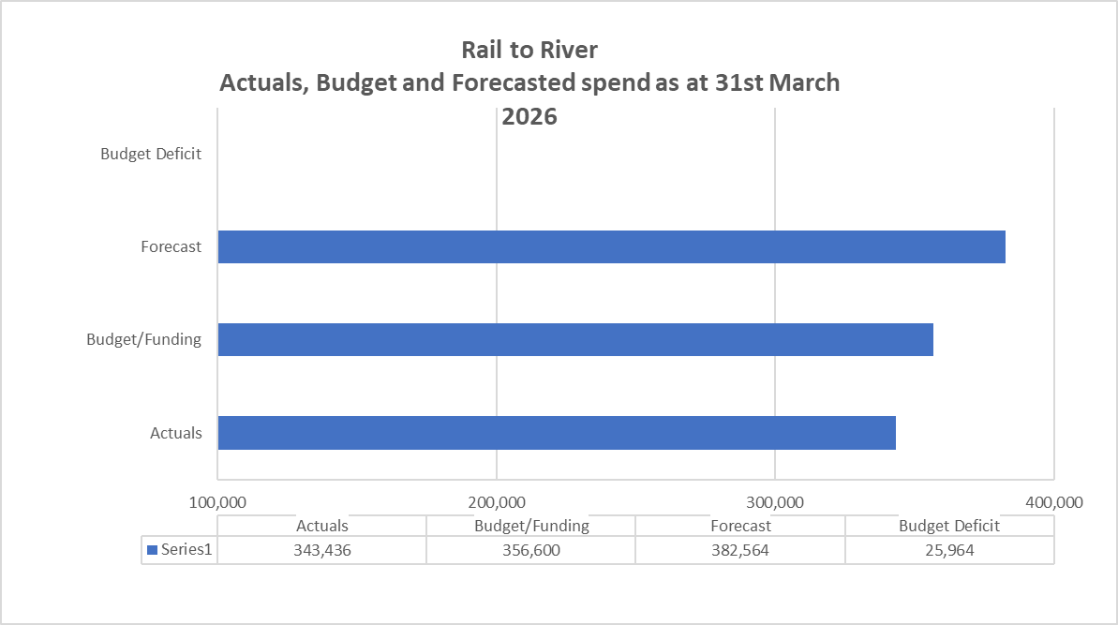
3.2 Financial Commentary
Financials RAG Status maintained at GREEN.
- As of 31st March 2026, project costs are £0.34m against a budget of £0.3.
- Forecasted costs are £0.38m with a £0.026m deficit which potentially UKSPF can cover if the work on the archway is completed by September 2026.
3.3 Project Contingency and Change Control
Change Ref |  |  | Description |  |  |  |  |  | Cost Impact |  |  |  |  | Programme Impact |  |  |  | Other Impact |  |  |  |  | RAG Status |  |  |  |  | Approval given by |  |  |  | Date of change
4. Timelines – High Level Milestones
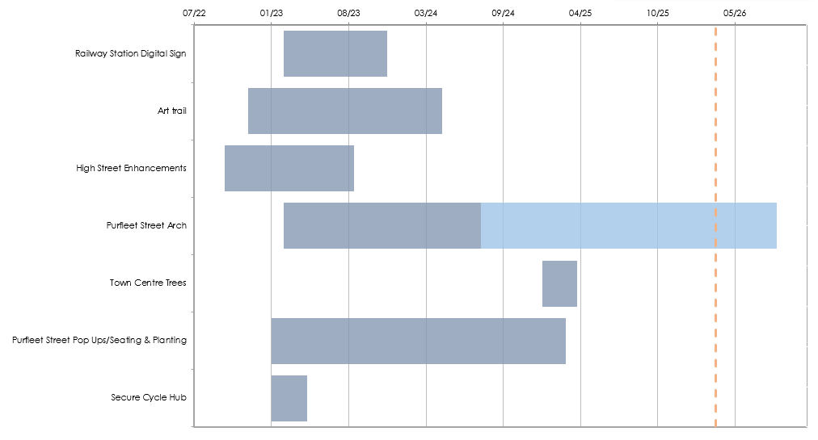
4.1 Timelines Commentary
Timelines currently RAG rated AMBER.
- The proposed Arch at Purfleet Street remains the only outstanding item.
- Procurement of the arch was paused due to the scaffold and ongoing issue with Boots not completing the licence for attachment. This delay does not affect funding timescales.
- All other items have been installed/completed.
5. Resources Commentary
The RAG Status for Resources currently rated GREEN.
- The Project Officer is due to go on maternity leave in June 2016 which will require a re-allocation of resource to complete the arch/artwork element of the project if it is decided that this will go ahead.
6. Communications and Engagement
- New photography with the new vendor will be used in press release and social media comms related to the Spring relaunch of the Pop Ups.
7. Outputs and Outcomes
7.1 Outputs
Description |  |  |  |  |  |  |  |  |  |  |  |  |  |  |  | Target |  |  |  | Notes
Increased footfall in the town centre |  |  |  |  |  |  |  |  |  |  |  |  |  |  |  | 5%
Footfall counts |  |  |  |  |  |  |  |  |  |  |  |  |  |  |  | 1
Number of transport nodes with new multimodal connection points (cycle storage) |  |  |  |  |  |  |  |  |  |  |  |  |  |  |  | 1350m2
Amount of public realm improved m² |  |  |  |  |  |  |  |  |  |  |  |  |  |  |  | 5
No of businesses supported |  |  |  |  |  |  |  |  |  |  |  |  |  |  |  | 5+ |  |  |  | 4 pop up units supporting a number of businesses throughout the project.
No of trees planted |  |  |  |  |  |  |  |  |  |  |  |  |  |  |  | 5 |  |  |  | 14 trees planted
Number of Finger post installations |  |  |  |  |  |  |  |  |  |  |  |  |  |  |  | 30 |  |  |  | 29, last one to be installed in Jan 2025.
Number of artwork installations |  |  |  |  |  |  |  |  |  |  |  |  |  |  |  | 3 |  |  |  | Including archway, 2 currently installed.
7.2 Outcomes
Description |  |  |  |  |  |  |  |  |  |  |  |  |  |  |  | Notes
Increased footfall in the town centre
Improve the accessibility and attractiveness of key routes
Improve the perception of the place by residents, visitors and businesses
8. Other Matters
Item |  |  |  |  |  |  |  |  |  |  |  |  |  |  |  | Comment
General stage progress |  |  |  |  |  |  |  |  |  |  |  |  |  |  |  | Design and installation: Railway Station Benches and planting – complete Digital Sign – complete Artwork x 2 – complete. Purfleet Street Arch – delayed. All planning and NCC licenses in place. Purfleet Street Pop Ups and street furniture installed. Utilities – water and electricity connections installed, issue with drainage resolved. Installed Cycle hub – complete. Purfleet Street planters- complete.
Procurement progress |  |  |  |  |  |  |  |  |  |  |  |  |  |  |  | Individual project elements; with in house co-ordination. Remaining orders to place – new Purfleet Street arch order.
Proposed form of contract (e.g., JCT, NEC, Traditional, D&B) |  |  |  |  |  |  |  |  |  |  |  |  |  |  |  | A variety of contracts will be used. In some cases, they are suppliers T&C’s, in other they are on standard council terms. As we do not have a one stop shop approach, each element is procured independently, and the council is acting as the contractor.
Proposed route to market (e.g., IOTT, Framework i.e. DPS, HPCS, LCP) |  |  |  |  |  |  |  |  |  |  |  |  |  |  |  | Single source supply for digital sign, containers, steelwork cladding, and archway. Other - Invitations to Quote, Locally Advertised, and approved local contractors as per standing orders.
Legal progress |  |  |  |  |  |  |  |  |  |  |  |  |  |  |  | License to fix arch to Boots and Cashino buildings with legal. Flyover licenses with NCC for archway. Pitch licenses with NCC and Street trading licences for pop ups. Application for tables and seating required by NCC - complete. Application for planters on highway required by NCC complete.
Local schemes / dependencies |  |  |  |  |  |  |  |  |  |  |  |  |  |  |  | Licensing process for digital signage with Network Rail has conditional approval. Final information of as fitted drawing and fire stopping report needed from Hollywell to complete sign off- being sought from Hollywell.
9. Approved Documents
 |  | OBC  [RIBA 0 Approval] |  |  |  |  |  | Client Brief [RIBA 1 Initiation] |  |  |  |  | Resource Brief |  |  | PID  [RIBA 1 Gateway] |  |  |  | PID Update  [RIBA 2 Gateway] |  |  |  | PID Update  [RIBA 3 Gateway] |  |  |  |  |  | PID Update  [RIBA 4 Design) |  |  |  | Final PID  [pre-post tender]
Status: |  | ✔ |  |  |  |  |  | ✔ |  |  |  |  | ✔ |  |  | ✔ |  |  |  | ✔ |  |  |  | ✔
Date Approved: |  | Jan 2022 |  |  |  |  |  |  |  |  |  |  |  |  |  |  |  |  |  |  |  |  |  | Feb 2023
Approved by: |  | KLTB |  |  |  |  |  |  |  |  |  |  |  |  |  |  |  |  |  |  |  |  |  | KLTB
Latest approved document: PID November 2023

Spend – Budget variance (Inc. Contingency) |  |  |  |  |  |  |  |  |  |  |  | Milestone Delivery RAG Status |  |  |  |  |  |  |  |  |  | Risk & Issue RAG status
R | More than 10% over or under budget |  |  |  |  |  |  |  |  |  |  | R | 13 weeks or more behind the critical path |  |  |  |  |  |  |  |  | R |  | Need immediate attention
A | Between 5% & 10% over or under budget |  |  |  |  |  |  |  |  |  |  | A | 4 to 12 weeks behind the critical path |  |  |  |  |  |  |  |  | A |  | Needs attention before next project review
G | Within 5% of budget or less than £10k |  |  |  |  |  |  |  |  |  |  | G | 4 to 12 weeks less behind the critical path |  |  |  |  |  |  |  |  | G |  | Can be managed

