P.21-16 |  |  |  | King’s Lynn Library  Project Highlight Report
Project Name: |  | King’s Lynn Library |  |  |  | Project Manager |  |  | Verity Bennett |  |  | Project Sponsor: |  |  |  | Sarah Rhoden |  |  |  |  |  | Report covers period of: |  |  |  | March 2026
Capital Code: |  |  | C8435 |  |  |  |  | Client Dept: |  |  |  | NCC Community Services |  |  |  |  |  | Lead Designer: |  |  |  |  | Hudson Architects
 |  |  |  |  |  |  |  |  |  |  |  |  |  |  |  |  |  | Cost Consultant: |  |  |  |  | Turner and Townsend
Project Code: |  |  | P.21-16 |  |  |  |  | End User (if applicable: |  |  |  | King’s Lynn residents and visitors to the town |  |  |  |  |  | Contractor on Site: |  |  |  |  | Mace
Management Summary
 |  |  |  | 1.Overall Status |  |  | 2.1 Risks |  |  |  | 2.2. Issues |  |  | 3.Financials |  |  |  |  |  | 4.Timelines |  |  |  | 5.Resources
This Report |  |  |  | G |  |  | G |  |  |  | G |  |  | G |  |  |  |  |  | G |  |  |  | G
Last Report |  |  |  | A |  |  | A |  |  |  | G |  |  | G |  |  |  |  |  | G |  |  |  | G
Project Definition
Project Stage: RIBA Stage 5
Objectives:
- Develop a co-located ‘community multi-use hub’ facility in the town centre of King’s Lynn
- Provide skills and educational opportunities for residents starting at entry level. Develop new community adult learning education and higher education courses that meet skills needs in the Town.
- Develop new community partnerships to provide a variety of programming and community support offers from the hub
- Provide services and facilities for start-ups and local businesses
Scope: To create a modern, accessible library, learning, and community hub in the heart of King’s Lynn town centre.
1. Overall Status (high-level summary)
Overall RAG status is GREEN
- The library has opened to the public!
1.1 Decisions required by the Neighbourhood Board
- No decisions required this month
1.2 Achievements during this period
- The library successfully opened to the public on Monday 16th March
2. Risks and Issues
2.1 Key Risks [all red and increasing amber] – something that may happen
Risk ID  (0/25) | Risk Title |  |  | Description |  |  |  |  |  | RAG Status |  |  | Risk Category |  |  |  | Mitigation |  |  |  |  |  |  |  |  |  | Dated Comments
2.2 Key Issues [all red and increasing amber] – something that has happened
Issue ID  (0/2) | Issue Title |  |  | Description |  |  |  |  |  | RAG Status |  |  |  |  | Issue Type |  |  |  | Resolution Plan |  |  |  |  |  | Dated Comments
Note: further detail on Project Risks and Issues can be found in the Risks and Issues Log.
Note: will vary for each project

3.1 Financial Summary
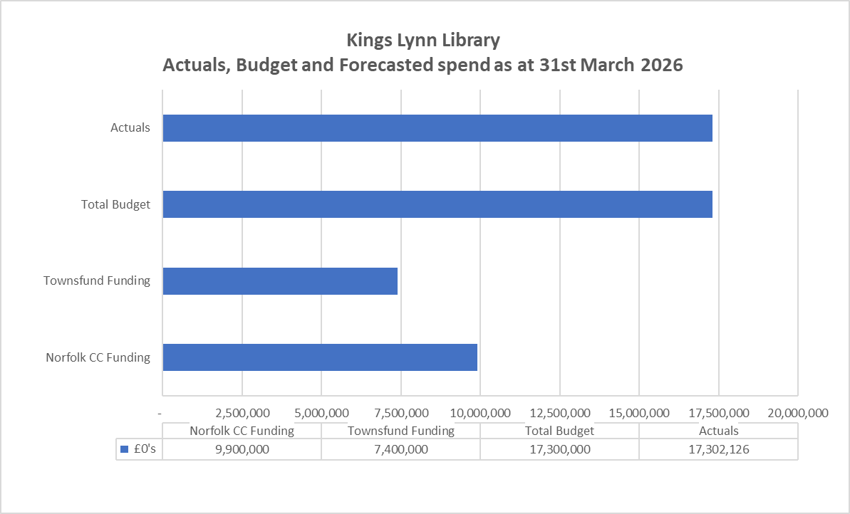
3.2 Financial Commentary
The Financial RAG rating is GREEN
- Total project actuals to date are £17.3m against an updated budget of £17.3m and is on budget. Some minor costs are still expected over the coming months along with some credit notes for flooring and other.
- Overall, the project is forecasted to be on budget at £17.3m
- Costs in this financial year total £12.5m, with prior year costs totalling £4.8m.
- The funding from the Town Deal fund was £7.4m and £9.9m from Norfolk County Council, totalling £17.3m.
3.3 Project Contingency and Change Control
Change Ref |  | Description |  |  |  | Cost Impact |  |  | Programme Impact |  |  | Other Impact |  |  |  | RAG Status |  |  |  |  |  | Approval given by |  |  |  | Date of change
N/A

4. Timelines – High Level Milestones
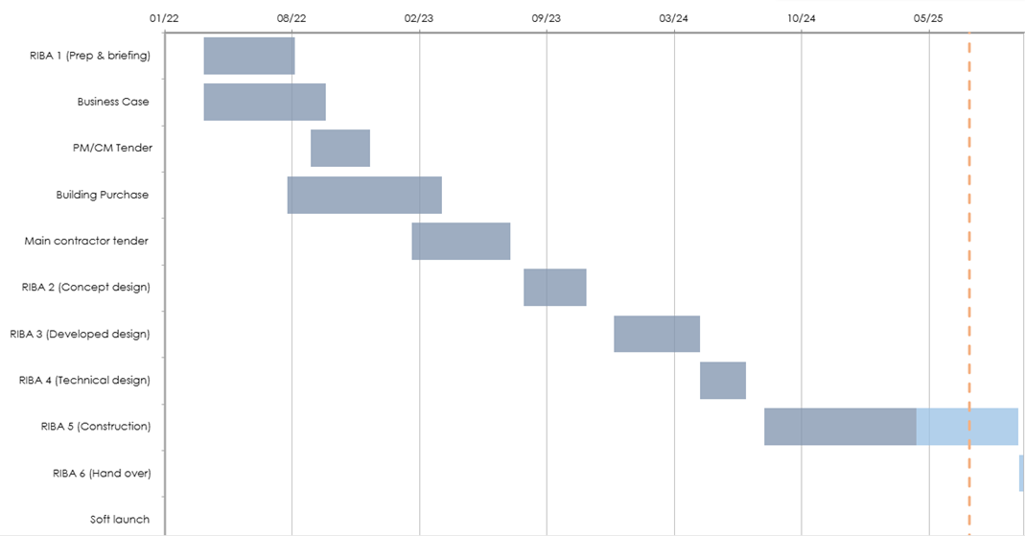
4.1 Timelines Commentary
The library has opened to the public
5. Resources Commentary
Resources remain GREEN
6. Communications and Engagement
- The library successfully opened its doors on Monday 16th March.
- The first week we welcomed 8297 visitors (compared to 911 on the equivalent week last year)
- Book issues for week one was up 277% and new member registrations up 2661%
- We have been running tours of the new facilities, and these have been fully booked every day since opening.
- Clubs restart in the library w/c 30th March and Adult Learning courses start properly after Easter.
7. Outputs and Outcomes
Outcomes
Description |  |  |  |  |  |  |  | Target |  |  |  |  | Notes
Amount of capacity of new or improved training or education facilities |  |  |  |  |  |  |  | 5,200
Number of learners enrolled in new education and training courses |  |  |  |  |  |  |  | 100pa
Number of learners / trainees / students enrolled at improved education and training facilities |  |  |  |  |  |  |  | 350pa
Number of learners/students/trainees gaining certificates, graduating or completing courses at new or improved training or education facilities, or attending new courses |  |  |  |  |  |  |  | 100pa
# of potential entrepreneurs assisted to be enterprise ready |  |  |  |  |  |  |  | 32pa
Improved perceptions of place by residents, visitors, and businesses |  |  |  |  |  |  |  | 70%
Increased footfall to the town centre |  |  |  |  |  |  |  | 200,000 pa²⁵
Outputs
Description |  |  |  |  |  |  |  |  |  |  | Targets |  |  |  |  |  |  | Notes
Number of new cultural facilities |  |  |  |  |  |  |  |  |  |  | 1 |  |  |  |  |  |  | 1
Number of derelict buildings refurbished |  |  |  |  |  |  |  |  |  |  | 1 |  |  |  |  |  |  | 1
Number of public amenities / facilities created` |  |  |  |  |  |  |  |  |  |  | 1 |  |  |  |  |  |  | 1
Amount of new office space – meeting rooms and hot desking |  |  |  |  |  |  |  |  |  |  | 400sqm |  |  |  |  |  |  | 400sqm
Amount of floor space repurposed (commercial) – spaces available for commercial hire |  |  |  |  |  |  |  |  |  |  | 425sqm |  |  |  |  |  |  | 425sqm
# of transport nodes with new multimodal connection points |  |  |  |  |  |  |  |  |  |  | 1
8. Other Matters
Item |  |  |  |  |  |  |  |  |  |  | Comment
General stage progress |  |  |  |  |  |  |  |  |  |  | RIBA Stage 5, Construction
Procurement progress |  |  |  |  |  |  |  |  |  |  | As above
Proposed form of contract (e.g. JCT, NEC, Traditional, D&B) |  |  |  |  |  |  |  |  |  |  | JCT Design and Build (D&B)
Proposed route to market (e.g. IOTT, Framework i.e. DPS, HPCS, LCP) |  |  |  |  |  |  |  |  |  |  | Framework
Legal progress |  |  |  |  |  |  |  |  |  |  | Exchange and Completion on building complete
ICT, FF&E update |  |  |  |  |  |  |  |  |  |  | FF&E development in progress
Stakeholder engagement (comms) |  |  |  |  |  |  |  |  |  |  | As above
Local schemes / dependencies |  |  |  |  |  |  |  |  |  |  | Concept study of Baxter’s Plain public realm (outside scope of MUCH)
9. Approved Documents
 |  | OBC  [RIBA 0 Approval] |  | Client Brief [RIBA 1 Initiation] |  | Resource Brief |  |  |  | PID  [RIBA 1 Gateway] |  | PID Update  [RIBA 2 Gateway] |  | PID Update  [RIBA 3 Gateway] |  |  |  |  |  |  | PID Update  [RIBA 4 Design) | Final PID  [pre-post tender]
Status: |  | ✔ |  | ✔ |  | ✔ |  |  |  | ✔ |  | ✔ |  | ✔ |  |  |  |  |  |  | ✔ | ✔
Date Approved: |  |  |  | Sept 22 |  | Nov 22 |  |  |  | May 23 |  | July 23 |  | Jun 24 |  |  |  |  |  |  | Jun 25
Approved by: |  |  |  | TDB |  | TDB |  |  |  | PB |  | PB |  | PB |  |  |  |  |  |  | PB
Last approved document: PID May 2023
Spend – Budget variance (Inc. Contingency) |  |  |  |  |  |  | Milestone Delivery RAG Status |  |  |  |  |  |  |  | Risk & Issue RAG status
R | More than 10% over or under budget |  |  |  |  |  | R |  | 13 weeks or more behind the critical path |  |  |  |  |  | R |  | Need immediate attention
A | Between 5% & 10% over or under budget |  |  |  |  |  | A |  | 4 to 12 weeks behind the critical path |  |  |  |  |  | A |  | Needs attention before next project review
G | Within 5% of budget or less than £10k |  |  |  |  |  | G |  | 4 to 12 weeks less behind the critical path |  |  |  |  |  | G |  | Can be managed

