P.21-11 |  |  |  |  |  |  |  | St George's Guildhall & Creative Hub  Project Highlight Report
Project Name: |  |  |  |  | St George's Guildhall & Creative Hub |  |  | Project Manager: |  | Robin Lewis / Dan Mason/ Liam Bacon |  |  |  |  |  | Project Sponsor: |  |  |  |  |  | Duncan  Hall |  |  |  |  |  | Report covers period of: |  |  |  |  | March 2026
Capital Code: |  |  |  |  | C9061 |  |  | Client Dept: |  |  |  | Regeneration |  |  |  |  | Lead Designer: |  |  |  |  |  |  |  |  |  |  |  |  | Haworth Tompkins
 |  |  |  |  |  |  |  |  |  |  |  |  |  |  |  |  | Cost Consultant: |  |  |  |  |  |  |  |  |  |  |  |  | Andrew Morton Associates
Project Code: |  |  |  |  | P.21-11 |  |  | End User (if applicable: |  |  |  | CIO * |  |  |  |  | Contractor on Site: |  |  |  |  |  |  |  |  |  |  |  |  | Messenger Construction LTD (started 24/11/2025)
Management Summary
 |  |  |  |  |  |  |  | 1.Overall Status |  |  | 2.1 Risks |  |  |  | 2.2. Issues |  |  |  |  |  | 3.Financials |  |  |  |  |  |  |  | 4.Timelines |  |  |  | 5.Resources
This Report |  |  |  |  |  |  |  | A |  |  | A |  |  |  | A |  |  |  |  |  | A |  |  |  |  |  |  |  | G |  |  |  | A
Last Report |  |  |  |  |  |  |  | A |  |  | A |  |  |  | A |  |  |  |  |  | A |  |  |  |  |  |  |  | G |  |  |  | A
Project Definition
Project Stage: RIBA Stage 5 – Construction
Objectives:
The project has the following defined aims:
- Redevelopment and refurbishment of St George’s Guildhall, from road to river, including a fully working Theatre.
- To conserve and promote King’s Lynn’s heritage and culture, and in particular draw upon the links between William Shakespeare and the Guildhall.
- Make our centre fully accessible and welcoming to all, whilst boosting new skills, and supporting new and existing creative businesses.
- To establish a vibrant cultural hub that will be a heritage attraction, education resource, commercial zone by day, and a theatre and entertainment venue by night.
Scope:
- Delivery of project outputs as identified in Towns Fund application & subsequent approved PAR summer 2024.
- Delivery of works identified in RIBA Stage 1-5 report(s) including alterations to the listed buildings necessary to deliver the scheme.
- Fundraising for capital and revenue costs as necessary
- Promotion of the project and centre its links to Shakespeare within the town nationally and internationally.
- Delivery of activities to widen the engagement, support wider cultural, learning, and educational objectives for the town and develop existing and new audiences.
- Creation of the CIO to operate the world class venue.
1. Overall Status (high-level summary)
RAG Status this month is AMBER.
Focus continues to find and deliver further funding for the project. As previously reported, external fundraising consultant has been appointed and are receiving their on-boarding instructions.

- Main Contract Works – Scaffold erection across the site is ongoing. Roof to Guildhall is nearing completion, despite challenges with the first burst water mains on King Street. The design team continues to release key information in line with the IRS schedule. No delays reported at this stage. Sunday 1st March – initial repairs to first water leak in King Street failed. Reactions by MCL/ team now underway – insurance claim being prepared.
- Fundraising - Historic England Grant works are well underway, second payment received (£151k) and final payment (£295k) has been requested. Various monthly performance, evaluation outputs are due next month. The award also conditions that the BC will spend c£525k by end of June 2026 on specific ongoing or new scoped works. These works are planned into the works schedule.
- Party wall - Despite continuous efforts, scaffold licenses/ party wall agreements to Wetherspoons & 2+3 Ferry Lane are still unsigned. Wetherspoons are not responding to escalated requests. 2+3 Ferry Lane are seeking unreasonable demands. BC legal back to back with these issues and preparing for possible enforcement next steps. These delays are now impacting MCL who seek to flex their programme to work-around things, but time is now getting critical.
- Interpretation Works – Immersive experience consultant tender period is nearly completed, and results have been issued to tenderers. Following the February meeting with the Interpretation designer (PLB) preparation is under way for the immersive consultants join the team.
- King Street public realm – Pre-App Public engagement runs 23 March – 17th April. 25th public drop in event at Nos 29. Late April. May final review before submission to planning (possibly PD) and highways.
- Crown Post Truss Peter McCurdy/ Momentum contracted to design the truss and connections strategy. MCL being asked to complete heritage works and installation in house given experience.
1.1 Decisions required by the Neighbourhood Board
- None required at this Board

1.2 Achievements during this period
- A mains water pipe has burst on King Street for a second time during the previous period putting the scaffolding structural stability at risk. The contractor has again worked with Anglian Water to ensure our scaffolding is safe while they carry out repair works. All additional costs for these works will be claimed via the water company’s insurance in time.
- Demolition works are progressing well with removal of BoH & some external staircases to Guildhall and opening up works to proposed café area (existing back of house area on ground floor). Shakespeare barn roof and main structure has been demolished ready for slab removal and archaeological dig of white lift pit to begin.
- Scaffolding to the roof is fully completed and Guildhall roof demolition has begun. Red Barn roof demolition has also been bought forward.
- Value Engineering progress continues. The team, MCL, Wadys M&E subcontractor working on alternate ideas.
- Timber condition survey to Guildhall roof structure has been completed on site, we await results back but early indications were positive.

Priorities for Next Period:
- Finalise Wetherspoon scaffold licence and begin erection of scaffolding to north range to allow roofing and wall repair works to commence. Should this fail, escalation legally maybe only option.
- Complete roof removal to Guildhall ready for timber repairs.
- Continue to monitor works and progress on site, respond to RFIs and review any challenges raised by the contractor.
- Finalise and submit S278 works and planning applications for King Street public realm. Gain firm costing from MCL.
- Onboard immersive experience consultant and fully restart this workstream
2. Risks and Issues
2.1 Key Risks [all red and increasing amber] – something that may happen
Risk ID |  | Risk Title |  |  |  | Description |  |  |  |  |  | RAG Status |  | Risk Category |  |  |  |  |  | Mitigation |  |  |  |  |  |  |  |  |  |  |  |  |  | Dated Comments
081 |  | Party Wall & Scaffolding Licences |  |  |  | Party wall licences and scaffold licences are we delayed due to start dates not being finalised and challenges with neighbouring properties. This could cause a delay & additional cost if they are not in place when MCL need to start works on these areas. |  |  |  |  |  | R |  | Party Wall |  |  |  |  |  | Working with Party wall surveyor and neighbouring properties to agree licences. We are also working with MCL to prioritise areas where their programme is due to start first. Escalation via General Manager at Wetherspoons to seek internal update as silence from their Surveyor.  Work continues on 2,3 Ferry Lane options. Various update have continued during March to close the gap in demands. |  |  |  |  |  |  |  |  |  |  |  |  |  | 02/04/2026
003 |  | Funding |  |  |  | Whilst the project has secured overall funding for the scheme (Towns Fund / BC/ others etc.) The commitment remains that every opportunity needs to be explored to reduce long term financial BC commitment. (March 2026 £15.5m) |  |  |  |  |  | A |  | Finance |  |  |  |  |  | Fundraising Consultant Cause4 now on board. Onboarding and strategy review and update due early in their brief. Actions then to take up the main part of their scope and raise funds. CIO key to success and getting their assurance/ polices in place is a priority at this time. |  |  |  |  |  |  |  |  |  |  |  |  |  | 02/04/2026
29 |  | Discovery of  Unidentified conditions |  |  |  | Unforeseen building works |  |  |  |  |  | A |  | Programme |  |  |  |  |  | Further Timber surveys underway incl various roof/ structure.  New lift pit excavation will be likely to impact sensitive archaeology. Access only available post Shakespeare Barn demolition planned for April 2026. Option to open test pits in the higher risk areas under consideration with MCL.  Guildhall roof timbers under review appear in reasonable condition. Restaurant conversely appear poor and will require a design/ scope update as they cannot be left as found. |  |  |  |  |  |  |  |  |  |  |  |  |  | 02/04/2026
44 |  | Programme |  |  |  | Construction Contract programme is 30 months. Post Contract it’s expected that Client Fitout/ Interpretation/ Immersive experience needs considering formally. |  |  |  |  |  | A |  | Financial |  |  |  |  |  | We hold regular programme reviews with the main contractor to ensure optimal scheme in place. |  |  |  |  |  |  |  |  |  |  |  |  |  | 02/04/2026
18 |  | Asbestos |  |  |  | Asbestos and other hazardous substances present within areas being stripped back / refurbished. Impacts to additional cost |  |  |  |  |  | A |  | Hazardous substance |  |  |  |  |  | Refurbishment and Demolition survey has been undertaken to areas that are to be worked on / disturbed. Enabling works package completed prior to main works package to derisk.  MCL have largely completed the known asbestos on site and minor discovery finds have been instructed / expected to be complete shortly. |  |  |  |  |  |  |  |  |  |  |  |  |  | 02/04/2026
78 |  | Historic England funding grant compliance. |  |  |  | The planned start date for works involving the Historic England Grant have shifted from Oct to Nov potentially impacting on the fund deadlines. |  |  |  |  |  | A |  | Funding |  |  |  |  |  | Remaining risk is to provide HE with Crown Post Truss designs/ install methodology. |  |  |  |  |  |  |  |  |  |  |  |  |  | 02/04/2026
79 |  | Planning & Listed Building discharge notices |  |  |  | While trying to discharge some condition discharge applications the planners have noted that the team cannot discharge conditions while trying to vary an approved application. This could cause delay. |  |  |  |  |  | A |  |  |  |  |  |  |  | Application to vary condition has now been approved. The design team continue working to discharge other conditions to minimise any delay to programme. |  |  |  |  |  |  |  |  |  |  |  |  |  | 02/04/2026
61 |  | Historic Timber (structural/ degradation status |  |  |  | Guildhall site timber in roof structures are in poor condition resulting in additional repair / replacement works. Infestation risk on timber beam in undercroft. |  |  |  |  |  | A |  |  |  |  |  |  |  | Timber surveys now completed to all areas other than GH roof. Final area will be completed once MCL have installed crash deck to guildhall area.  Specialist areas are also under review by timber specialist.  Degradation levels in Guildhall main historic floor timers are greater than first thought. Design review and potential amendments to scheme to protect/ provide on-going future access under consideration at what could be additional costs. |  |  |  |  |  |  |  |  |  |  |  |  |  | 02/04/2026
2.2 Key Issues [all red and increasing amber] – something that has happened
Issue ID |  |  |  |  | Issue Title |  |  | Description |  |  |  | RAG Status |  |  |  |  |  |  | Issue Type |  |  |  |  | Resolution Plan |  |  |  |  |  | Dated Comments
Issues are being tracked separately due to the scale of this project
3. Project Financials
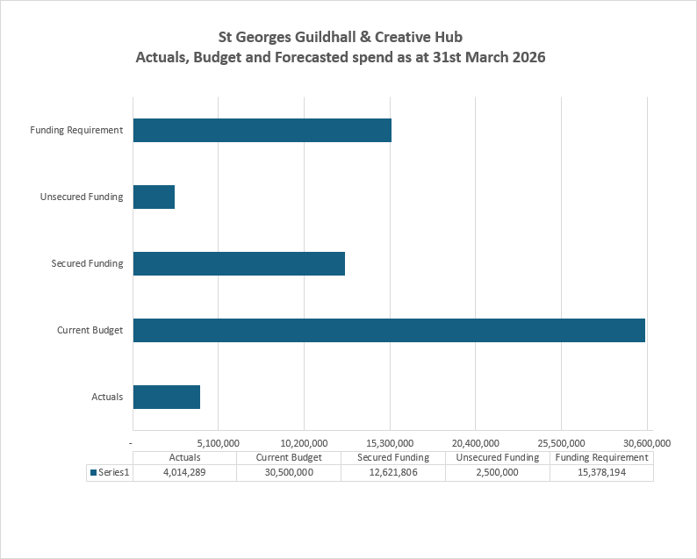
3.1 Financial Commentary
Financial RAG status is currently AMBER .
- Actuals including year-end accruals as of 31st March 2026 are £4m with a current project budget of £30.5m.
- Funding is £12.6m of secured funding, £2.5m of unsecured funding and £15.4m is the current funding requirement, where work is ongoing to locate further funding for the project. Revenue funding of £0.7k is being reviewed.
- Actuals primarily relate to professional and consulting costs, including Project Management, Quantity Surveyor, and architect costs, with the main contractor costs to date are £1.2m, of which c£0.9m are actuals and £0.3m are accruals as at 31st March 2026.
3.2 Project Contingency and Change Control
Change Ref |  |  | Description |  |  |  |  |  | Cost Impact |  | Programme Impact |  |  | Other Impact |  |  |  |  | RAG Status |  |  |  |  | Approval given by |  |  |  |  |  |  |  | Date of change
Formal change control tracker being prepared for use during the RIBA5 + Project timelines, to capture delegated/ various Project Governance thresholds.

4. Timelines – High Level Milestones
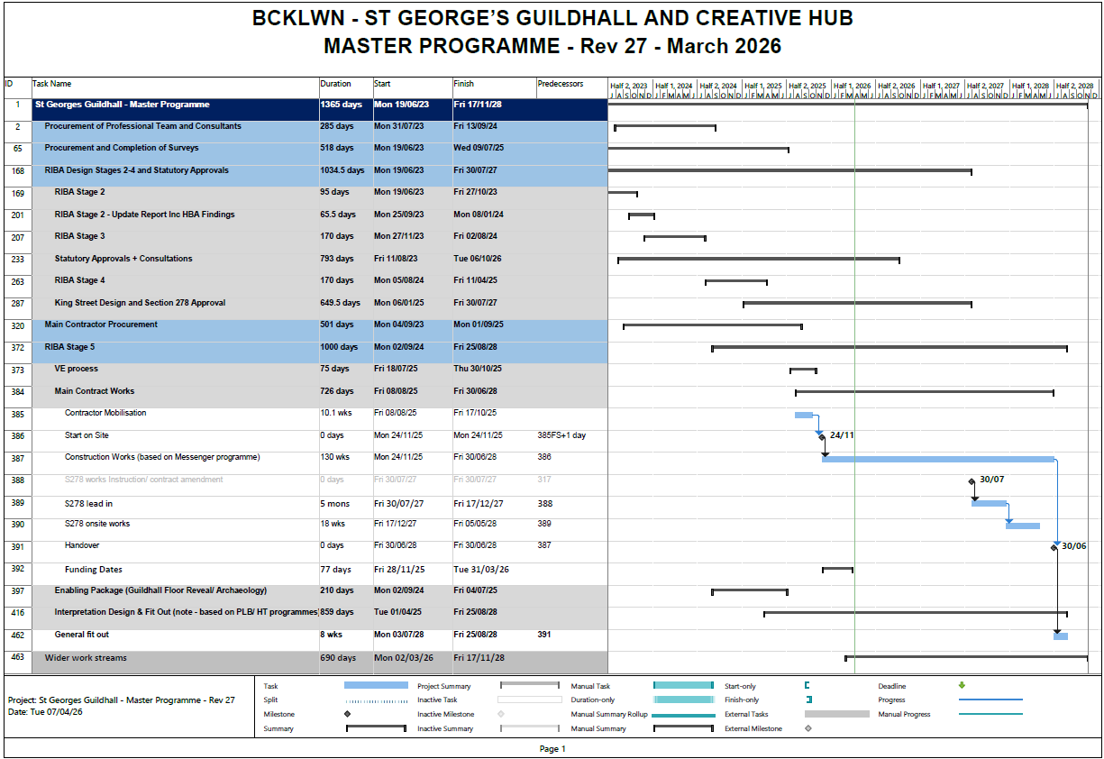
4.1 Timelines Commentary
Timeline RAG rating is Green.
- Contractor advised of potential delay (due to scaffolding/ Party wall issues as noted elsewhere.) They are obliged to issue notice and then validate agree details over the coming weeks/ month. Any impact, given the wider programme opportunities to increase MCL outputs, will be reviewed in due course
- Monitor risk on timeline following second water leak matters on King Street
- Bringing Interpretation Design workstream and Immersive designer into a jointly agreed plan
- Onboarding known design (archaeological) finds together, agreeing budget, timeline, and instructions to MCL
5. Resources Commentary
Resource this month is Amber.
- Pre-opening resource, eventing and operational under review. (TFH, MM, RL)
- Historic England Award requirements continue to be highly demanding of officers/ consultant time.
- Wider Programme workstream governance requirements review completed. Proposed approach is that programme key areas are broken into x5 Workstreams. Update to internal roles/ reporting underway from April. Further detailed updates to follow in May/June.
6. Communications and Engagement
- Messenger Social Value KPI schedule drafted including all key metrics called out during the tender. Targets continue to be worked on.
- External Hoarding to King Street Guildhall montage being prepared for sign off and placing on this important public facing feature of the works. Delay to installation continues due to temporary modifications required due to water leak works.
7. Outputs and Outcomes
7.1 Outputs
Description |  |  |  |  |  |  |  |  |  |  |  | Target |  |  |  |  |  |  |  |  |  |  |  | Full Scheme revised outputs, agreed by KLTB and BCKLWN Cabinet July 2024 and 2025
Number of temporary FT jobs supported during project implementation |  |  |  |  |  |  |  |  |  |  |  | 110 |  |  |  |  |  |  |  |  |  |  |  | 55
Number of full-time equivalent (FTE) permanent jobs created through the projects |  |  |  |  |  |  |  |  |  |  |  | 22 |  |  |  |  |  |  |  |  |  |  |  | 34
Number of improved cultural facilities |  |  |  |  |  |  |  |  |  |  |  | 5 |  |  |  |  |  |  |  |  |  |  |  | 8
Amount of capacity of new or improved training or education facilities |  |  |  |  |  |  |  |  |  |  |  | 1*
Amount of capacity of new or improved training or education facilities |  |  |  |  |  |  |  |  |  |  |  | 10,300 |  |  |  |  |  |  |  |  |  |  |  | 10,300
# of derelict buildings refurbished |  |  |  |  |  |  |  |  |  |  |  | 6 |  |  |  |  |  |  |  |  |  |  |  | 6
# of heritage buildings renovated/restored |  |  |  |  |  |  |  |  |  |  |  | 10 |  |  |  |  |  |  |  |  |  |  |  | 10
# of enterprises receiving non-financial support |  |  |  |  |  |  |  |  |  |  |  | 50 |  |  |  |  |  |  |  |  |  |  |  | 50
# of potential entrepreneurs assisted to be enterprise ready |  |  |  |  |  |  |  |  |  |  |  | 60 |  |  |  |  |  |  |  |  |  |  |  | 60
Amount of existing parks/greenspace/outdoor improved |  |  |  |  |  |  |  |  |  |  |  | 1240 m² |  |  |  |  |  |  |  |  |  |  |  | 1572m2
Amount of new office space |  |  |  |  |  |  |  |  |  |  |  | 669m² |  |  |  |  |  |  |  |  |  |  |  | 825m2
Mandatory indicator - Year on Year monthly % change in footfall |  |  |  |  |  |  |  |  |  |  |  | 900% |  |  |  |  |  |  |  |  |  |  |  | 1680%
NEW – Improvement to King Street Public Realm (subject to planning) |  |  |  |  |  |  |  |  |  |  |  |  |  |  |  |  |  |  |  |  |  |  |  | 350m2
7.2 Outcomes
Description |  |  |  |  |  |  |  |  |  |  |  | Notes
Refurbishing the Historic Theatre and enhancing physical access – with a reference to its exceptional historical value and Shakespearian connection |  |  |  |  |  |  |  |  |  |  |  | RIBA 04 Design details the site wide improvements to access for both the public and members of staff working there in the future scheme.
Creating opportunities for local creative enterprises |  |  |  |  |  |  |  |  |  |  |  | The creative hubs will provide a real base for these new enterprises.
Creating inspiring spaces, for the community and visitors alike, for formal and informal learning including youth engagement. |  |  |  |  |  |  |  |  |  |  |  | The scheme has many flexible meeting and public discussion spaces across the 10 buildings on the site. Community engagement continues to build on many positive news stories about place and the needs of local people.
8. Other Matters
Item |  |  |  |  |  |  |  |  |  |  |  | Comment
General stage progress |  |  |  |  |  |  |  |  |  |  |  | Contract signed and construction to commence 24/11/2025.
Procurement progress |  |  |  |  |  |  |  |  |  |  |  | Main Contractor tender completed.
Proposed form of contract (e.g. JCT, NEC, Traditional, D&B) |  |  |  |  |  |  |  |  |  |  |  | Construction – JCT with quantities & 8 amendments following review
Proposed route to market (e.g. ITT, Framework i.e. DPS, HPCS, LCP) |  |  |  |  |  |  |  |  |  |  |  | Procurement will be via a two-stage tender (SQ followed by full ITT), open market tender via the Councils procurement portal
Legal progress |  |  |  |  |  |  |  |  |  |  |  | Support development of CIO governing document, Fundraising guidance for both BCKLWN to share with CIO/ NT to ensure compliance with law, Charity Commission, the Lease between the BCKLWN, and NT. HMRC Tax rules
Legal instruction form issued. |  |  |  |  |  |  |  |  |  |  |  | Legal instruction issued in October 2022 for development of CIO agreement & then again in Sept/October 2024 in relation to fundraising for the site and its operation.
Surveys Status |  |  |  |  |  |  |  |  |  |  |  | Surveys identified and completed RIBA4. Ongoing risk e.g. timber conditions being monitored and further archaeological “rescue” matters subject to survey/appointment. Focus of recent finds in foyer floor/ Shakespeare passage/ Undercroft, Main stage area built into design changes being worked through in this period.
Statutory updates |  |  |  |  |  |  |  |  |  |  |  | Extensive coordinated updates with National Trust, plus Planning, Development Team and Building Control to ensure views are captured during design and delivery process. Conservation Officer regularly gathered to support any updates to approved scheme. It appears new planning applications not required but variations to be agreed. A new LBC application needed (you cannot vary LB consents.) i.e. to cover sprinkler tank change, Lightening protection requirements continue to be under review. Ecologist and Construction Management plans focus to discharge ahead of start on site
Local schemes / dependencies |  |  |  |  |  |  |  |  |  |  |  | Other Towns & PfN Deal programme and projects. PAR from Riverfront to support reallocation of funds to the Guildhall.  Wider BCKLWN work including update of Cultural Strategy and volunteering.  Work with National Trust and Norfolk Museum Service regarding visitor trends
9. Approved Documents
 |  |  |  | OBC  [RIBA 0 Approval] |  |  | Client Brief [RIBA 1 Initiation] |  |  | Resource Brief |  |  | PID  [RIBA 1 Gateway] |  |  |  |  | PID Update  [RIBA 2 Gateway] |  |  |  |  |  |  | PID Update  [RIBA 3 Gateway] |  |  |  |  |  | PID Update  [RIBA 4 Design) |  |  |  | Final PID  [pre-post tender]
Status: |  |  |  | ✔ |  |  | ✔ |  |  | - |  |  | ✔ |  |  |  |  | ✔ |  |  |  |  |  |  | ✔ |  |  |  |  |  | ✔ |  |  |  | ✔
Date Approved: |  |  |  | 24/06/22 |  |  | 21/12/22 |  |  | - |  |  | 21/12/22 |  |  |  |  | 30/11/23 |  |  |  |  |  |  | 09/07/24 |  |  |  |  |  | 28/03/25 |  |  |  | 7th & 17th July 2025
Approved by: |  |  |  | Cabinet |  |  | TF Prog Board |  |  | - |  |  | TF Prog Board |  |  |  |  | OMPB |  |  |  |  |  |  | Project Board |  |  |  |  |  | Town Board |  |  |  | Cabinet, Full Council Town Board,
Latest approved document: PID July 2025
Spend – Budget variance (Inc. Contingency) |  |  |  |  |  |  |  |  |  | Milestone Delivery RAG Status |  |  |  |  |  |  |  |  |  |  |  |  |  |  | Risk & Issue RAG status
R | More than 10% over or under budget |  |  |  |  |  |  |  |  | R | 13 weeks or more behind the critical path |  |  |  |  |  |  |  |  |  |  |  |  |  | R | Need immediate attention
A | Between 5% & 10% over or under budget |  |  |  |  |  |  |  |  | A | 4 to 12 weeks behind the critical path |  |  |  |  |  |  |  |  |  |  |  |  |  | A | Needs attention before next project review
G | Within 5% of budget or less than £10k |  |  |  |  |  |  |  |  | G | 4 to 12 weeks less behind the critical path |  |  |  |  |  |  |  |  |  |  |  |  |  | G | Can be managed

