P.21-12 |  |  |  |  |  | Active & Clean Connectivity Project Highlight Report
Project Name: |  |  | Active & Clean Connectivity |  |  |  |  |  |  |  | Project Manager: |  |  |  |  |  |  | Mike Auger |  |  |  |  | Project Sponsor: |  |  |  | Duncan  Hall |  |  |  |  |  |  |  | Report covers period of: |  |  |  | March 2026
Capital Code: |  |  | C9063/71609 |  |  |  |  |  | Client Dept: |  |  |  |  |  |  | N/A |  |  |  |  |  |  |  | Lead Designer: |  |  |  |  |  | LCWIP – Norfolk County Council  ATH – Morgan Sindall
 |  |  |  |  |  |  |  |  |  |  |  |  |  |  |  |  |  |  |  |  |  |  |  | Cost Consultant: |  |  |  |  |  | ATH – Andrew Morton Associates (AMA)
Project Code: |  |  | P-21.12 |  |  |  |  |  | End User (if applicable: |  |  |  |  |  |  | BCKLWN Commercial Services |  |  |  |  |  |  |  | Contractor on Site: |  |  |  |  |  | LCWIP –Norfolk County Council/Tarmac  ATH – TBC
Management Summary
 |  |  |  |  |  |  | 1.Overall Status |  |  |  |  |  |  | 2.1 Risks |  |  |  |  |  |  |  | 2.2. Issues |  |  |  |  | 3.Financials |  |  |  |  |  |  |  | 4.Timelines |  |  |  | 5.Resources
This Report |  |  |  |  |  |  | A |  |  |  |  |  |  | A |  |  |  |  |  |  |  | A |  |  |  |  | G |  |  |  |  |  |  |  | A |  |  |  | G
Last Report |  |  |  |  |  |  | A |  |  |  |  |  |  | A |  |  |  |  |  |  |  | R |  |  |  |  | A |  |  |  |  |  |  |  | A |  |  |  | G
Project Strands Summary
 |  |  |  |  |  |  | 1. Overall Status |  |  |  |  |  |  | 2.1 Risks |  |  |  |  |  |  |  | 2.2. Issues |  |  |  |  | 3. Financials |  |  |  |  |  |  |  | 4.Timelines |  |  |  | 5. Resources
Active Travel Hub Enterprise Park |  |  |  |  |  |  | A |  |  |  |  |  |  | A |  |  |  |  |  |  |  | A |  |  |  |  | G |  |  |  |  |  |  |  | A |  |  |  | G
Active Travel Hub Baker Lane |  |  |  |  |  |  | A |  |  |  |  |  |  | A |  |  |  |  |  |  |  | A |  |  |  |  | A |  |  |  |  |  |  |  | A |  |  |  | G
LCWIP Interventions |  |  |  |  |  |  | G |  |  |  |  |  |  | G |  |  |  |  |  |  |  | G |  |  |  |  | G |  |  |  |  |  |  |  | G |  |  |  | G
Active Travel Planning |  |  |  |  |  |  | G |  |  |  |  |  |  | G |  |  |  |  |  |  |  | G |  |  |  |  | G |  |  |  |  |  |  |  | G |  |  |  | G
Project Definition
Project Stage: ATH - RIBA 4 / Tender, LCWIP - Delivery, ATP – Partial completion / behavioural change
Objectives: To deliver the vision of promoting active travel as a safe and attractive modal option, reducing congestion and improving air quality.
Scope: The project will deliver a package of measures including
- Priority schemes identified in the Local Cycling & Walking Infrastructure Plan (LCWIP),
- King’s Lynn Enterprise Zone Active Travel Hub (EZ ATH)
- Baker Lane Active Travel Hub
- Active Travel Plan Fund (revenue)
1. Overall Status (high-level summary)
Overall RAG Status is AMBER.
- Active Travel Hub Enterprise Zone –Planning permission denied for Baker Lane Active Travel Hubs at March 2026 committee. Lead Local Flood Authorities (LLFA) requested extension to consultation period for King’s Lynn Enterprise Park (KLEP) Active Travel Hub (ATH) placing application with report to reach committee in May 2026.
- LCWIP – Final LCWIP scheme to deliver crossing at Gayton Road complete and final accounts due in April 2026.
- Active Travel Plans – Work ongoing with College of West Anglia (CWA) and Queen Elizabeth Hospital (QEH).
- With the remaining budget, the project team are assessing options for additional activities to encourage active travel in 2026.
1.1 Decisions required by the Neighbourhood Board
- Decision on next steps for Baker Lane Active Travel Hub
- Progression of KLEP ATH subject to planning approval
1.2 Achievements during this period
LCWIP
- Gayton Road, final LCWIP scheme completed in early March 2026. Scheme completed inline with forecast cost with final account due in April 2026
Active Travel Hubs
- Following Baker Lane ATH planning refusal in March 2026, project team have investigated options available to address committees’ comments and take project forward.
- Discussions still ongoing with Lead Local Flood Authority (LLFA) regarding KLEP ATH. LLFA have asked for further extension for response which puts pressure on proposal being heard at May 2026 Planning Committee.
- Morgan Sindall pricing exercise complete with updated costs due at start of April 2026. Following review contracts will be due to be signed in May 2026.
2. Risks and Issues
2.1 Key Risks [all red and increasing amber] – A risk something that may happen
Risk ID  (2/24) |  | Risk Title |  |  |  |  |  | Description |  |  |  |  |  |  |  |  |  |  |  | RAG Status |  |  |  | Risk Category |  |  |  | Mitigation |  |  |  |  |  |  |  |  |  |  |  |  |  | Dated Comments
12 |  | ACC Financial |  |  |  |  |  | Increasing project costs require changes to project scope and deliverables meaning programme unable to meet programme outcomes and deliver full benefits of the project. |  |  |  |  |  |  |  |  |  |  |  | A |  |  |  | Financial |  |  |  | Morgan Sindall are finalising pricing exercise to issue at start of April.  Due to Baker Lane planning decision, the programme for the project will need to be extended to allow for the delivery of the hub at this site. The impact of this change is still being assessed by Morgan Sindall. |  |  |  |  |  |  |  |  |  |  |  |  |  | 02.04.26
24 |  | ATH Planning |  |  |  |  |  | Ongoing planning discussions with LLFA may extend the overall programme |  |  |  |  |  |  |  |  |  |  |  | A |  |  |  | Programme / Financial |  |  |  | Despite ongoing engagement with LLFA, a further extension to their consultation has been requested. Project Team working to ensure KLEP application still heard at May committee. |  |  |  |  |  |  |  |  |  |  |  |  |  | 02.04.26
2.2 Key Issues [all red and increasing amber] – An issue something that has happened
Issue ID  (1/12) |  | Issue Title |  |  |  |  |  | Description |  |  |  |  |  |  |  |  |  |  |  | RAG Status |  |  |  | Issue Type |  |  |  | Resolution Plan |  |  |  |  |  |  |  |  |  |  |  |  |  | Dated Comments
12 |  | Planning |  |  |  |  |  | The Baker Lane planning application has been denied by the planning authority. This decision prevents progression to the construction phase and places significant risk on the programme timeline, budget, and deliverability of the intended project outcomes. |  |  |  |  |  |  |  |  |  |  |  | A |  |  |  | Programme / Financial / Project Outcomes |  |  |  | The project team are continuing to analyse the planning authority’s reasons for refusal and have developed an options note to discuss the potential next steps for the project including the financial/programme and output impacts for the project. |  |  |  |  |  |  |  |  |  |  |  |  |  | 02.04.26
Note: further detail on Project Risks and Issues can be found in the Risks and Issues Log.
3. Project Financials
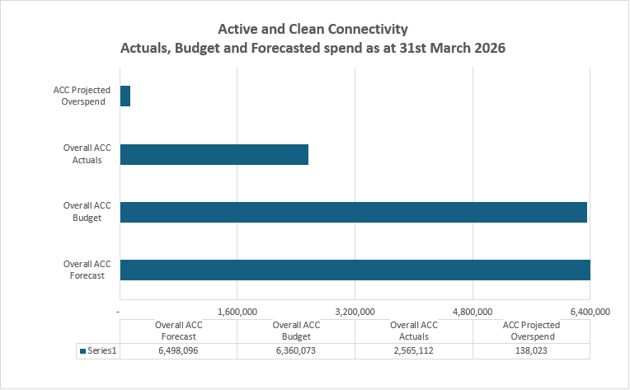
3.1 Financial Commentary
RAG rating status is currently Green following approval of Enterprise Zone cabinet paper was approved in early mark which included £0.6m of funds for the ACC project.
- Actuals to date from inception in 2021 to 31st March 2026 are £2.6m against an overall budget of £6.4m.
- Costs in this 2025-26 financial year, 2025-26 from 1st April 2025 to 31st March 2026 total’s £1.5m primarily related to £0.9m of LCWIP Norfolk County Council costs, main contractor costs and consultancy costs.
- The Enterprise Zone cabinet paper was approved in early mark which included £0.6m of funds for the ACC project.
- There is an overall projected overspend of £0.13m, this is new costs for offsite credits, the drainage board and S278 cost agreement abortive costs, at present the £0.3m contingency hasn’t been used to cover these costs but is available is required.
- Active Travel Plans - Work ongoing with CWA and QEH. Potential walking campaign to follow in early 2026
3.2 Project Contingency and Change Control
Change Ref |  |  |  |  | Description |  |  |  |  |  |  | Cost Impact |  |  |  |  |  |  | Programme Impact |  |  |  |  |  |  | Other Impact |  |  |  |  |  |  | RAG Status |  |  |  | Approval given by |  |  |  | Date of change
1 |  |  |  |  | LCWIP reprioritisation of interventions |  |  |  |  |  |  | N/A – preserves budget and contingency |  |  |  |  |  |  | N/A |  |  |  |  |  |  | Clarifies delivery expected from NCC |  |  |  |  |  |  | G |  |  |  | David Ousby |  |  |  | 02.12.22
2 |  |  |  |  | Removal of 2 LCWIP schemes from programme to be delivered by alternative funding. |  |  |  |  |  |  | Allocated budget repurposed to wider ACC programme. |  |  |  |  |  |  | N/A – works part of current programme of LCWIP works |  |  |  |  |  |  | N/A |  |  |  |  |  |  | G |  |  |  | TDB |  |  |  | 26.04.24
3 |  |  |  |  | Tennyson Avenue scheme removed from LCWIP interventions to be taken by future funding. |  |  |  |  |  |  | Allocated budget repurposed to wider ACC programme. |  |  |  |  |  |  | N/A |  |  |  |  |  |  | N/A |  |  |  |  |  |  | G |  |  |  | TDB |  |  |  | 23.08.24
4 |  |  |  |  | Old Meadow Road removed from LCWIP interventions with associated budget transferred to Riverfront Project. |  |  |  |  |  |  | Allocated budget repurposed to wider Town Deal programme. |  |  |  |  |  |  | Reduction in length of new footway/cycleway to be delivered. |  |  |  |  |  |  | N/A |  |  |  |  |  |  | G |  |  |  | TDB |  |  |  | 24.10.25
4. Timelines – High Level Milestones
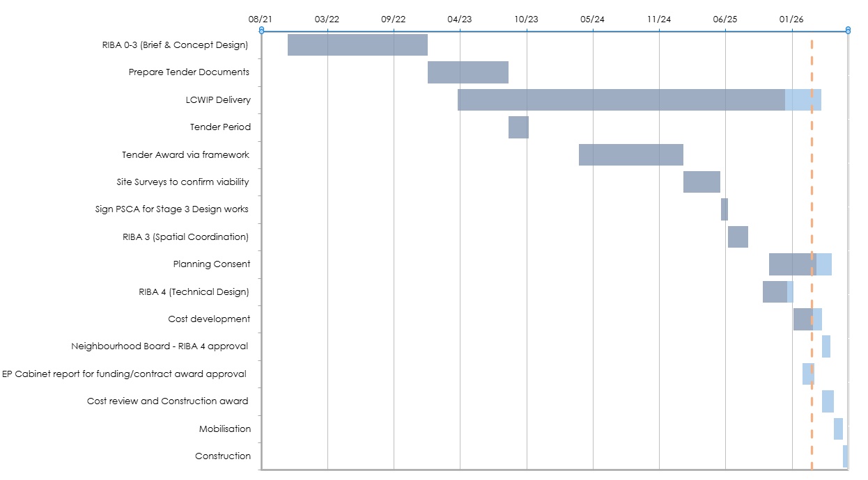
4.1 Timelines Commentary
The current timeline RAG rating is AMBER.
- This is due to the ongoing planning discussions with LLFA regarding the KLEP ATH which may delay the proposed start of works and therefore extend the overall programme timeline.
- The Baker Lane planning decision prevents the planned progression to the construction phase and places significant risk on the programme timeline while the reasons for refusal are assessed and the resolution route identified.
- Final LCWIP works delivered through March 2026.
5. Resources Commentary
Resources RAG rating maintains as GREEN due to the following:
- Pulse Project Management support to the project.
- Appointment of Morgan Sindall to progress the site investigation works to progress the ATH projects
6. Communications and Engagement
Activity programmed for forthcoming months:
- Update on progress of Active Travel Hub schemes being developed following recent planning progress.
- NCC Sustainable Transport Communications Campaign - “Real People on Bikes” evaluation due with walking campaign being scheduled early 2026.
- Work to showcase the successful delivery of the LCWIP schemes being developed with NCC communications team.
7. Outputs and Outcomes
Outputs
Description |  |  |  |  |  |  |  |  |  |  |  |  |  |  |  |  |  |  |  |  |  |  | Target |  |  |  |  |  |  |  | Note
Total length of new cycle ways |  |  |  |  |  |  |  |  |  |  |  |  |  |  |  |  |  |  |  |  |  |  | 3.555km |  |  |  |  |  |  |  | Following the stopping of Old Medow Road, the project is now expected to deliver 0.44 km of new cycle ways.
Total length of pedestrian paths improved |  |  |  |  |  |  |  |  |  |  |  |  |  |  |  |  |  |  |  |  |  |  | 5.601km |  |  |  |  |  |  |  | 7.7 km delivered
Alternative fuel charging / re-fuelling points |  |  |  |  |  |  |  |  |  |  |  |  |  |  |  |  |  |  |  |  |  |  | 6
New out of town car parking spaces |  |  |  |  |  |  |  |  |  |  |  |  |  |  |  |  |  |  |  |  |  |  | 50
Cycle parking spaces |  |  |  |  |  |  |  |  |  |  |  |  |  |  |  |  |  |  |  |  |  |  | 48
New transport nodes with new multimodal connection points |  |  |  |  |  |  |  |  |  |  |  |  |  |  |  |  |  |  |  |  |  |  | 2
In addition to the outputs set out in the application the project has delivered 7 schemes to provide improved connectivity through improved crossing facilities and removal of barriers
Outcomes
Description |  |  |  |  |  |  |  |  |  |  |  |  |  |  |  |  |  |  |  |  |  |  | Notes
Improve affordability, convenience, reliability and sustainability of travel options to and from places of work and places of interest (especially shops and amenities)
Reduce congestion within the town
8. Other Matters
Item |  |  |  |  |  |  |  |  |  |  |  |  | Comment
General stage progress |  |  |  |  |  |  |  |  |  |  |  |  | ATH works being progressed through RIBA Stage 4 by Morgan Sindall procured through SCAPE framework  NCC delivering final LCWIP scheme in January 2026.  Mobilityways delivery Travel Plans with QEH and CWA with potential to recruit additional workplaces. Option being explored if can also support delivery of ATHs.
Procurement progress |  |  |  |  |  |  |  |  |  |  |  |  | ATH – contract being progressed with Morgan Sindall via Scape Framework  LCWIP – being progressed via NCC Highways Team and Service Term Contract  Project Management & QS – Pulse Consult and Andrew Morton Associates appointed through Borough Councils PM and QS framework.
Proposed form of contract (e.g. JCT, NEC, Traditional, D&B) |  |  |  |  |  |  |  |  |  |  |  |  | ATH – Scape Framework NEC4 D&B, LCWIP – NCC Service Term Contract NEC4
9. Approved Documents
 |  |  |  | OBC  [RIBA 0 Approval] |  |  |  |  |  | Client Brief [RIBA 1 Initiation] |  |  |  |  | Resource Brief |  |  |  |  |  | PID  [RIBA 1 Gateway] |  |  |  | PID Update  [RIBA 2 Gateway] |  |  |  | PID Update  [RIBA 3 Gateway] |  |  |  |  |  |  | PID Update  [RIBA 4 Design) |  |  |  | Final PID  [pre-post tender]
Status: |  |  |  | Nora ATH  Baker Lane ✔ |  |  |  |  |  | Nora ATH ✔  Baker Lane ✔ |  |  |  |  | Nora ATH ✔  Baker Lane ✔ |  |  |  |  |  | Nora ATH ✔  Baker Lane ✔ |  |  |  | Nora ATH ✔  Baker Lane ✔ |  |  |  | Nora ATH ✔  Baker Lane – Draft 1 |  |  |  |  |  |  | ATH PID final Draft - 20.03.23 |  |  |  | n/a
Date Approved: |  |  |  |  |  |  |  |  |  |  |  |  |  |  |  |  |  |  |  |  | NORA  31.01.22  Baker Lane 19.08.22 |  |  |  | NORA 07.03.22 Baker Lane – RIBA combined |  |  |  | NORA 15.07.22 Baker Lane draft issued 16.12.22 |  |  |  |  |  |  | Project board approval 20.03.23
Approved by: |  |  |  | Project Board |  |  |  |  |  | Project Board |  |  |  |  | Project Board |  |  |  |  |  | Project Board |  |  |  | Project Board |  |  |  | Project Board |  |  |  |  |  |  | Project Board
Last approved document: Various, see above

Spend – Budget variance (Inc. Contingency) |  |  |  |  |  |  |  |  |  |  |  |  |  |  |  | Milestone Delivery RAG Status |  |  |  |  |  |  |  |  |  |  |  |  |  |  |  | Risk & Issue RAG status
R | More than 10% over or under budget |  |  |  |  |  |  |  |  |  |  |  |  |  |  | R | 13 weeks or more behind the critical path |  |  |  |  |  |  |  |  |  |  |  |  |  |  | R |  | Need immediate attention
A | Between 5% & 10% over or under budget |  |  |  |  |  |  |  |  |  |  |  |  |  |  | A | 4 to 12 weeks behind the critical path |  |  |  |  |  |  |  |  |  |  |  |  |  |  | A |  | Needs attention before next project review
G | Within 5% of budget or less than £10k |  |  |  |  |  |  |  |  |  |  |  |  |  |  | G | 4 to 12 weeks less behind the critical path |  |  |  |  |  |  |  |  |  |  |  |  |  |  | G |  | Can be managed

